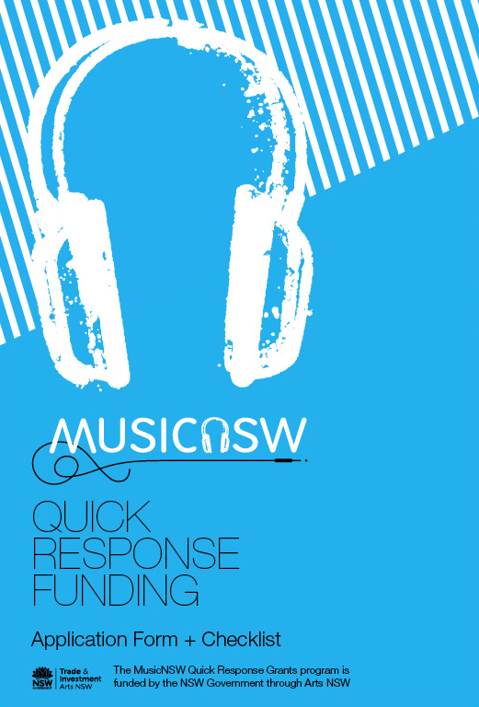

before you start
Before you begin your application read through the MusicNSW Quick Response funding FAQs and Guidelines to check:

- Opening and closing dates
- Eligibility requirements
- Selection criteria

You can download a copy of the guidelines here: http://www.musicnsw.com/funding/

Applicant contact details:

Band/musician Name:
(Your answer here)

Band Contact:
(Your answer here)

Management / Label contact:
(Your answer here)

Who is the primary contact for this application?
(your answer here – either band or management contact)

street address of Primary contact:
(Your answer here)

What is the local government area of the primary contact?
You can find this info out here: http://www.olg.nsw.gov.au/public/my-local-council/find-my-council

(Your answer here)

What is the State electorate of the primary contact?
You can find this info here: http://streetlist.elections.nsw.gov.au/
(Your answer here)

Postal Address (if different from street address):
(Your answer here)

MUSICNSW COMMUNITY NUMBER:
this is a free membership to MusicNSW, which provides many benefits. See here for details and how to apply:
(Your answer here)

Web Links:
(Please include all relevant links, i.e. band site, Facebook, soundcloud, YouTube channel etc)
(Your answer here)

Which conference or music industry event
are you applying to attend?
(Your answer here)

OR /

WHAT IS THE UNIQUE OPPORTUNITY YOU ARE APPLYING TO ATTEND?
(Your answer here)

Artistic Statement:
- Your artistic statement should talk about the band/artist, focusing on local achievements encompassing radio and airplay achievements, press exposure, live performance achievements and any other relevant information. This section will allow the assessment panel to determine your export-readiness, and how your attendance at the conference or support opportunity will capitalise on these achievements and open doors for new ones. A press-bio will not be accepted as a response to this category.
- Please refer to the selection criteria for best results.
- Your response should be no more than 600 words.
(Your answer here)

Management ProfilE:
Please respond to this section with a bio or CV that details the relevant professional details of your management.
- Your response should be no more than 600 words
(Your answer here)

Why do you wish to apply for this grant?
- Keeping in mind the selection criteria, and the focus on creating export-opportunities, as well as networking, educational and informative outcomes. What will this funding help you to achieve?
- Details around showcases you have been invited to play, meetings you have, or hope to set-up and outcomes you hope to achieve will be highly regarded.
- Please keep your response to 600 words.

(Your answer here)

Business impact Statement:
*NB, you only need to supply a Business Statement if you are a manager, label or publicist applying on behalf of yourself or a band.
Please respond to this section with a bio or CV that details the relevant professional details of your management, specifically referencing how the opportunity you are requesting funding for will positively impact your organisation and create opportunities for yourself and your artists.
(Your answer here)

TO ATTACH:

- Press Kit: Please attach as a separate document
- Images: Please attach to the email, with pictures not exceeding 1MB in size each.
- Budget: Please complete the budget template overleaf.

MusicNSW Export Quick Response Budget Template
All figures should relate to the totals relevant to the project (i.e. if the project is funding for a tour include the tour costs, rather than a per show cost).

Please note – in the application process, you are only required to fill out the “Estimate” column. If you are successful, you will acquit your budget in the “Actuals” column, post-event.

NB: Please refer to the Applications Guideline document for information around the budget.

INCOME | Project Budget (estimate) | Project Budget (actuals)
Performance Fee
Ticket Sales
Merchandising and retail
Fees and Services
Other - please specify:
Own Contribution (cash)
Own Contribution (in-kind)
State funding – Arts NSW
Federal funding – Australia Council
Other funding – please specify:

TOTAL EARNED INCOME
EXPENDITURE | Project Budget (estimate) | Project Budget (actuals)
Salaries/ Fees – Creative
Salaries/ Fees – Production
Salaries/ Fees – Professional Development (i.e. tickets, passes)
Venue Costs
Equipment, Lighting and Audio Visual costs
Staging and Materials
Other development + creative costs
Freight
Conferences and Workshops
Travel
Accommodation
Travel Allowances (per diems)
Contingency
Advertising (all media)
Promotional Materials
Marketing & PR Costs
Insurance
Other Admin costs – please specify:

TOTAL EARNED INCOME

NET SURPLUS/ (DEFICIT)

amount requested from musicnsw

